Chapter 2
IFRS2-4 What are some of the challenges to the IASB in developing a conceptual framework?
- Some of the challenges that the IASB is facing include:
- The basic principles of its framework are repeated which makes the board at times lose direction.
- The IASB seems to be having an issue with developing a cohesive body of principle-based standards.
- The IASB is having an issue with the pressure that is imposed of the board’s short-term commitment to come up with a roadmap on which they will converge with US GAAP (Henderson, 2013).

IFRS2-5 As discussed in Chapter 1, the International Accounting Standards Board (IASB) develops accounting standards for many international companies. The IASB also has developed a conceptual framework to help guide the setting of accounting standards. While the FASB and IASB have issued converged concepts statements on the objective and qualitative characteristics, other parts of their frameworks differ.

Instructions: Briefly discuss the similarities and differences between the FASB and IASB conceptual frameworks as related to elements and their definitions
- One of the similarity between the FASB and IASB is the manner in which they recognize stock-based compensation. Both FASB and IASB recognize that the fair value of shares and options that are available follows the idea that compensation should be taken as the time over which the person has served in the company. In both FASB and IASB, the due process for issuing IFRS entails financial analysts, accountants, and other users of financial statements (Henderson, 2013). Also, in both FASB and IASB equity-like instruments that are giving the holders rights to demand for settlements in form of cash should be classified as liabilities.
- One of the differences between the FASB and IASB is that of the features defining equity and debt. GAAP calls for reassessing by the entities on any embedded derivative should be kept side at the end of each reporting time, whereas IFRS only requires there to be a change if it is believed that there might be significant changes in the cash flow (Henderson, 2013). Another difference between FASB and IASB is that FASB comes up with GAAP whereas the ISAB comes up with IFRS.

IFRS2-6 Your aunt recently received the annual report for a company in which she has invested. The report notes that the statements have been prepared in accordance with IFRS. She has also heard that certain terms have special meanings in account-ing relative to everyday use. She would like you to explain the meaning of terms she has come across related to accounting.

Instructions Access the IASB conceptual framework at the IASB website (http://eifrs.iasb.org/ ). (Click on the IFRS tab and then register for free eIFRS access if necessary.) When you have accessed the documents, you can use the search tool in your Internet browser to pre-pare responses to the following items. (Provide paragraph citations.) (a) How is “materiality” defined in the framework?
According to the framework, materiality can be said to relate to the importance of transactions, errors found in the financial statements and the balances. In the case of aunt’s case, there could be some errors made in the financial reports which had been prepared on her behalf.
(b) Briefly discuss how materiality relates to (1) the relevance of financial information, and (2) completeness.
- Information is considered material if it is obscuring, misstating or leaving out some materials that could significantly influence the decisions that will be made by the financial statements users.
- Materiality relates to completeness in the sense that the information that is contained in the financial statements are complete in the materials that are required for them to present a true and fair view on the decisions relating to the organization (Bellandi, 2018).
(c) Your aunt observes that under IFRS, the financial statements are prepared on the accrual basis. According to the frame-work, what does “accrual basis” mean
- It means that the effects on the transactions had been recognized or recorded as they occurred and not as they were paid for. Also, under the accrual basis, the events that were recorded represented the accounting records that were reported and recorded on the financial statements of the periods in which they took place.
Chapter 3
E3-1 (L02) (Transaction Analysis—Service Company) Beverly Crusher is a licensed CPA. During the first month of opera-tions of her business (a sole proprietorship), the following events and transactions occurred.

April 2 Invested $32,000 cash and equipment valued at $14,000 in the business.
2 Hired an administrative assistant at a salary of $290 per week payable monthly.
3 Purchased supplies on account $700. (Debit an asset account.)
7 Paid office rent of $600 for the month. 11 Completed a tax assignment and billed client $1,100 for services rendered. (Use Service Revenue account.)
12 Received $3,200 advance on a management consulting engagement.
17 Received cash of $2,300 for services completed for Ferengi Co.
21 Paid insurance expense $110.
30 Paid administrative assistant $1,160 for the month.
30 A count of supplies indicated that $120 of supplies had been used.
30 Purchased a new computer for $6,100 with personal funds. (The computer will be used exclusively for business purposes.)

E3-5
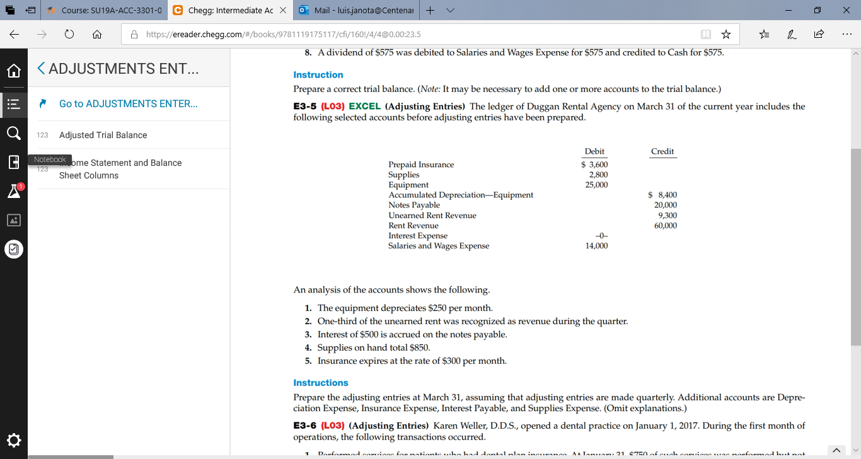

E3-6 (L03) (Adjusting Entries) Karen Weller, D.D.S., opened a dental practice on January 1, 2017. During the first month of operations, the following transactions occurred.
1. Performed services for patients who had dental plan insurance. At January 31, $750 of such services was performed but not yet billed to the insurance companies.
2. Utility expenses incurred but not paid prior to January 31 totaled $520.
3. Purchased dental equipment on January 1 for $80,000, paying $20,000 in cash and signing a $60,000, 3-year note payable. The equipment depreciates $400 per month. Interest is $500 per month. 4. Purchased a one-year malpractice insurance policy on January 1 for $12,000. 5. Purchased $1,600 of dental supplies. On January 31, determined that $500 of supplies were on hand.

Instructions Prepare the adjusting entries on January 31. (Omit explanations.) Account titles are Accumulated Depreciation—Equipment, Depreciation Expense, Service Revenue, Accounts Receivable, Insurance Expense, Interest Expense, Interest Payable, Prepaid Insurance, Supplies, Supplies Expense, Utilities Expenses, and Accounts Payable.

E3-8 (L03) EXCEL (Adjusting Entries) Andy Roddick is the new owner of Ace Computer Services. At the end of August 2017, his first month of ownership, Roddick is trying to prepare monthly financial statements. Below is some information related to unrecorded expenses that the business incurred during August.
1. At August 31, Roddick owed his employees $1,900 in wages that will be paid on September 1.
2. At the end of the month, he had not yet received the month’s utility bill. Based on past experience, he estimated the bill would be approximately $600.
3. On August 1, Roddick borrowed $30,000 from a local bank on a 15-year mortgage. The annual interest rate is 8%. 4. A telephone bill in the amount of $117 covering August charges is unpaid at August 31.

E3-15
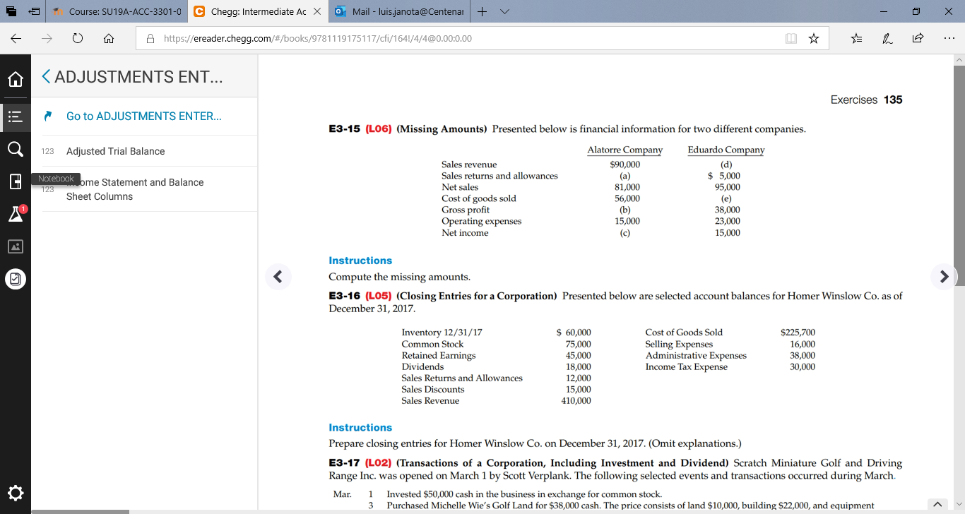

(a) Sales returns and allowances= sales revenue-net sales.
90000-81000= $9000
(b) Gross profit= net sales- cost of goods sold.
81000-56000 = $25000
(c) Net income= gross profit-operating expenses.
25000-15000= $10000
(d) Sales revenue= sales returns and allowances +net sales.
95000+5000=$100000
(e) Cost of goods sold= net sales-gross profit
95000-38000=$57000

E3-17
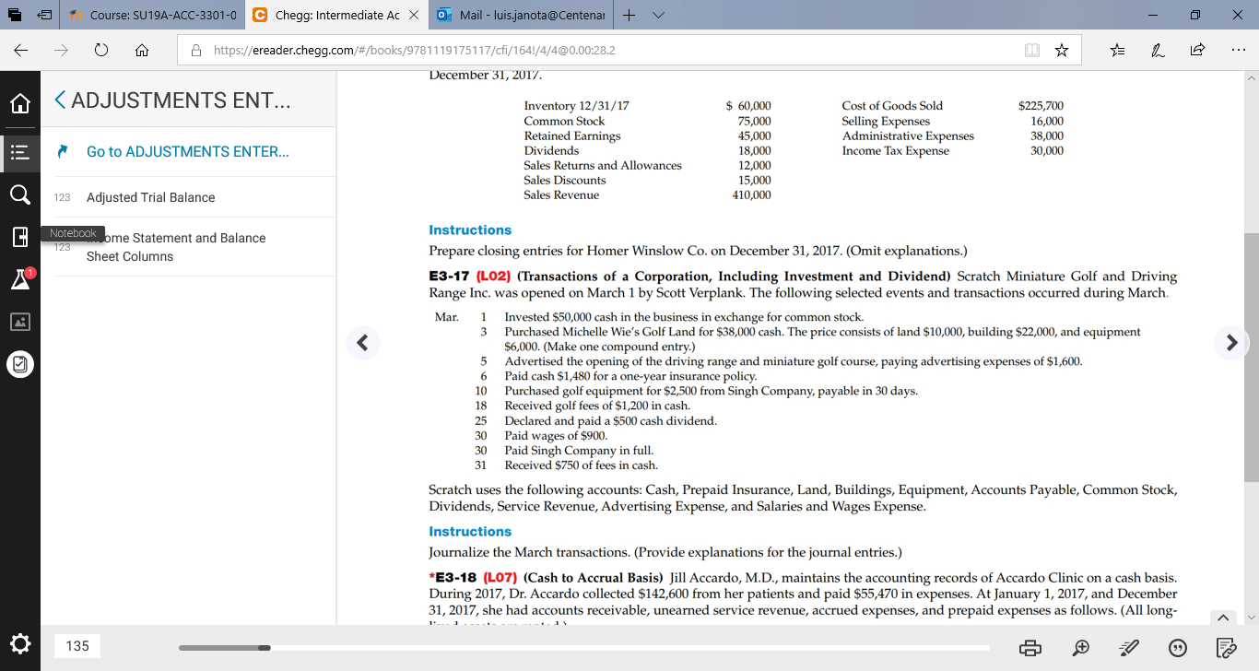

P3-1
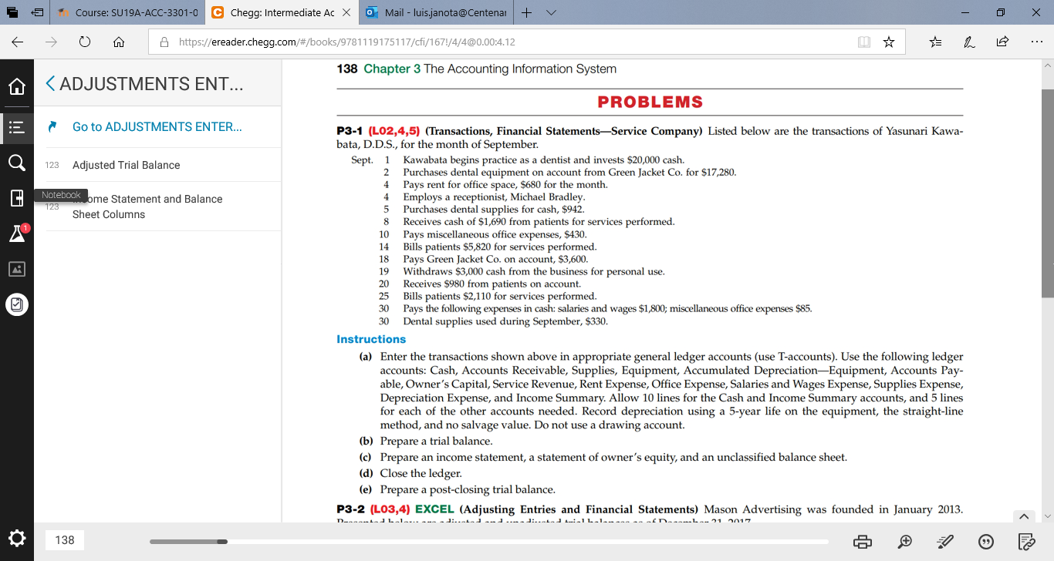

E4-5

Do you receive advertisements through e-mail? Are they directed toward any specific audience or product category? Which ads seem to be most prevalent? Do you pay much attention or just delete them? How much work is it to get off an advertising list?
Yes I do receive advertisements through e-mail. The advertisements are normally not directed to any specific audience. At times, the ads can be directed to specific product category depending on which type of product a person has signed-up for.
The ads that seem to be most prevalent are the ones from media houses such as CNN, and BBC.
I pay much attention to them as I am interested in knowing about the current events (news). However, I at times delete them without having gone through especially when I have much to look for in the email.
It is easy to get off an advertising list simply by signing out. This will imply that the person does not want to receive the das from that particular site.
E4-6

Why would or wouldn’t you try to get off the list? What is it about a company’s Web site that draws you to it, keeps you there on the site longer, and keeps you coming back for more? If you could summarize these answers into a set of criteria for Web sites, what would those criteria be?
I would try to get off a list of ads if I am fed up with seeing the ads and if I have completed a certain task that I had started so as to be receiving the news for.
I am attracted by a website that is posting educative materials which are up-to-date (current). A website that creates content that is engaging attracts my attention. Also, the site should be fast (increased speed).
A good website should entail content that is engaging and current. Also, the speed of browsing while on the website should be fast so that the person does not feel bored by the slow speed.
E4-8

Compare three different search engines. What tips do they provide to improve a page’s rankings? How much does it cost to advertise a page on their results pages? If you were a company, could you think of any situation where you would pay almost any amount to have the first listing on the first results page?
NOTE: (similar to the one below)

E4-9

Compare three different search engines. What tips do they provide to improve a page’s rankings? How much does it cost to advertise a page on their results pages? If you were a company, could you think of any situation where you would pay almost any amount to have the first listing on the first results page?

The top three search engines are Google, Bing and Yahoo
Engine market share
Bing 13.10%, Google 65.09% and Yahoo 15.89%
Yahoo Inc. is worth $17.7 billion, Google Inc. is worth $131.1 billion.
CEO Compensation
 | Google | Microsoft | Yahoo
 | Larry Page | Steven A. Ballmer | Timothy R. Morse  (Interim CEO)
Salary | $1 | $670,000 | $518,750
Other | $1,785 | $671,121 | $2,381,349
Total | $1,786 | $1,351,121 | $2,900,099

Google
Some of the ways to improve a page in Google include:
- Start with a sound foundation
- Optimize for mobile
- Optimize for speed
Bing
Some of the ways to improve a page ranking in Bing include:
- Get indexed
- Have the right technical
- Use straight forward keywords
Yahoo
Some of the ways to improve a page ranking in Yahoo include:
- Conduct keyword research
- Create engaging content
- Keep an eye on the news
Cost of advertising
Google: it will cost between $1-$2
Bing: averagely $1.54 cost per click
Yahoo: averagely $1-$2 per click.

Listing
Yes, I would pay so that the business becomes popular since it will then make large volumes of sales.

E4-13

Visit www.firstgov.gov.
What kind of services do you see that would help you?
Some of the services that would assist me include:
- Education
- Benefits, grants, loans.
- Jobs and unemployment.
- Money and taxes
- Travel and immigration.
What services would you use?
The services that I would use include:
- Education services
- Jobs services.
- Money and taxes.
- Travel and immigration services.
What areas are missing?
Some of the areas that are left out in this website include:
- Insurance
- Transport
- Energy

Reference
Bellandi, F. (2018). Materiality in financial reporting: An integrative perspective.
Henderson, S., & Peirson, G. (2013). Issues in Financial Accounting. Pearson Australia Pty Ltd.

